1. Minibatch starts at 64 and doubles every 20 epochs

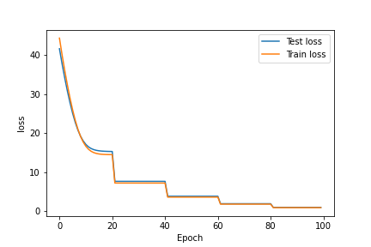

Loss function vs Epoch Number

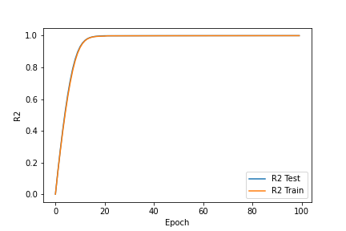

R2 vs Epoch Number

1. Fixed minibatch = 1024

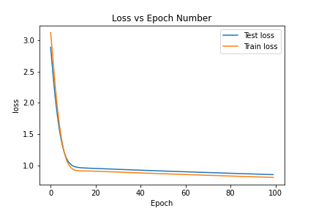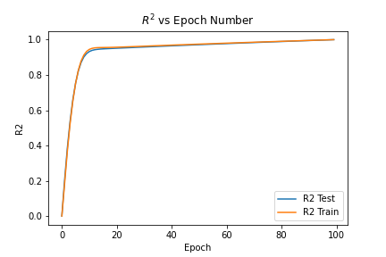

1. CNN Architecture

|  |  |  |  |  |  |
| --- | --- | --- | --- | --- | --- |
|  | Layer Description | Number of Filters | Kernel Size | Stride | Number of Parameters |
| Layer 1 | Conv2d | 16 | 5 | 1 | 1216 |
| Layer 2 | Conv2d + 2x2 max pooling | 16 | 5 | 1 | 6416 |
| Layer 3 | Conv2d + 2x2 max pooling | 32 | 5 | 1 | 12832 |
| Layer 4 | Conv2d + ReLU activation | 32 | 5 | 1 | 25632 |
| Layer 5 | Linear | 2048/1 |  |  | 2049 |
| Total Number of Parameters | 48145 |  |  |  |  |

1. Plot of residuals

#!/usr/bin/env python

# coding: utf-8

import numpy as np

import matplotlib.pyplot as plt

import torch

from torch.autograd import Variable

import torch.optim as optim

from torch.utils.data import DataLoader

import torch.nn as nn

import torch.nn.functional as F

import os

#use gpu and cuda for speedup

device = torch.device('cuda:0' if torch.cuda.is_available() else 'cpu')

class MyDataset(torch.utils.data.Dataset):

def __init__(self,folder,train):

super(MyDataset, self).__init__()

self.train = train

self.folder = folder

self.label_mean = 52.90

if self.train:

self.root = os.path.join(self.folder,"cnntrain")

else:

self.root = os.path.join(self.folder,"cnntest")

self.files = os.listdir(self.root) # take all files in the root directory

def __len__(self):

return len(self.files)

def __getitem__(self, idx):

#sample, label = torch.load(os.path.join(self.root, self.files[idx])) # load the features of this sample

sample = plt.imread(os.path.join(self.root, self.files[idx]))

sample = np.moveaxis(sample,-1,0)

#label = np.array(float((self.files[idx][-20:-18]))-self.label_mean).astype(float)

label = np.array(float((self.files[idx][-20:-18]))).astype(float)

#print(label)

sample,label = torch.from_numpy(sample).type(torch.FloatTensor),torch.from_numpy(label).type(torch.FloatTensor)

#label = label.view(-1,1)

return sample, label

class CNN(nn.Module):

def __init__(self, in_channels, out_channels):

super(CNN, self).__init__()

#Start the CNN architecture

#First CONV layer (16-filters)

self.conv1 = nn.Conv2d(in_channels = in_channels, out_channels = 16, kernel_size = 5, stride = 1)

#self.batch1 = nn.BatchNorm2d(16)

#First CONV -> POOL layer (16-filters)

self.conv2 = nn.Conv2d(in_channels = 16, out_channels = 16, kernel_size = 5, stride = 1)

self.pool = nn.MaxPool2d(kernel_size = 2, stride = 2)

#Second CONV -> POOL layer (32-filters)

self.conv3 = nn.Conv2d(in_channels = 16, out_channels = 32, kernel_size = 5, stride = 1)

#self.batch2 = nn.BatchNorm2d(32)

#First and only CONV -> ReLU layer (32-filters)

self.conv4 = nn.Conv2d(in_channels = 32, out_channels = 32, kernel_size = 5, stride = 1)

#self.relu = nn.ReLU(inplace=True)

#full connectivity layers

self.fc1 = nn.Linear(in_features= 2048, out_features = out_channels)

def forward(self, x):

x = self.conv1(x)

x = self.pool(self.conv2(x))

x = self.pool(self.conv3(x))

x = self.conv4(x)

#x = self.conv5(x)

#print(x.shape)

x = torch.flatten(x, 1)

#print(x.shape)

out = self.fc1(x)

#out = self.fc2(x)

return out

def main(fixed):

source_folder = "../datasets/cnn"

dataset_train = MyDataset(folder=source_folder, train=True)

dataset_val = MyDataset(folder=source_folder, train=False)

N_train = dataset_train.__len__()

N_test = dataset_val.__len__()

# defining the model

input_dim = (3, 64, 64) #3 channels in 64 x 64 images

model = CNN(3, 1)

# Define loss

loss_fn = nn.MSELoss(reduction='sum')

# Optimizer

if fixed == False:

learning_rate = 1e-8 / N_train

elif fixed == True:

learning_rate = 1e-8 / N_train

optimizer = optim.SGD(model.parameters(), lr = learning_rate, momentum=0.9, weight_decay = 0.0001)

# Move to GPU

model = model.to(device)

loss_fn = loss_fn.to(device)

test_loss = []

train_loss = []

R2_test = []

R2_train = []

for epoch in range(100):

print('EPOCH {}:'.format(epoch + 1))

batch_size = 0

#set up for part a and b of hw

if fixed == False:

if epoch <= 20:

batch_size = 64

elif epoch > 20 and epoch <= 40:

batch_size = 128

elif epoch > 40 and epoch <= 60:

batch_size = 256

elif epoch > 60 and epoch <= 80:

batch_size = 512

else:

batch_size = 1024

if epoch in list([0, 21, 41, 61, 81]):

loader_train = DataLoader(dataset=dataset_train, batch_size = batch_size)

loader_test = DataLoader(dataset=dataset_val, batch_size = batch_size)

optimizer = optim.SGD(model.parameters(), lr = learning_rate / (epoch + 1), momentum=0.9, weight_decay = 0.0001)

elif fixed == True:

batch_size = 1024

loader_train = DataLoader(dataset = dataset_train, batch_size = batch_size)

loader_test = DataLoader(dataset = dataset_val, batch_size = batch_size)

running_train_loss = 0

running_test_loss = 0

predictions_train, actuals_train = [], []

#make sure gradient tracking is on

model.train()

for data in loader_train:

inputs, labels = data

#inputs = (inputs - torch.mean(inputs)) / torch.std(inputs)

#print(inputs.shape,labels.shape)

# Zero gradients for every batch

optimizer.zero_grad()

#send to gpu

inputs = inputs.to(device)

labels = labels.to(device)

#Make prediction for this batch

outputs = model(inputs)

labels = labels.unsqueeze(1)

#Compute loss and its gradient

loss = loss_fn(outputs, labels)

loss.backward()

#adjust learning weight

optimizer.step()

#gather loss

running_train_loss += loss.item() / batch_size

#need to get values outside of loop

model.eval()

with torch.no_grad():

y_predicted_train_batch = model(inputs)

y_predicted_train_batch = y_predicted_train_batch.cpu().numpy()

actual = labels.cpu().numpy() #Copy the tensor to cpu

actual = actual.reshape((len(actual), 1))

# store y values from model

for element in y_predicted_train_batch:

predictions_train.append(element)

for element in actual:

actuals_train.append(element)

#print(np.array(predictions_train).shape,np.array(actuals_train).shape)

model.train()

train_loss.append(running_train_loss / N_train)

actuals_train, predictions_train = np.array(actuals_train).flatten(), np.array(predictions_train).flatten()

#actuals_train, predictions_train = torch.flatten(actuals_train), torch.flatten(predictions_train)

#print(actuals_train.shape,predictions_train.shape)

y_bar_train = np.mean(actuals_train)

#assert actuals_train.shape == predictions_train.shape

R2_train.append(1 - (np.sum(np.square(actuals_train - predictions_train)) / np.sum(np.square(actuals_train - y_bar_train))))

predictions_test, actuals_test = [], []

#Do not need gradients to do validation

model.eval()

with torch.no_grad():

for vdata in loader_test:

vinputs, vlabels = vdata

#vinputs = (vinputs - torch.mean(vinputs)) / torch.std(vinputs)

y_predicted_on_test_batch = model(vinputs.to(device))

vlabels = vlabels.to(device)

vlabels = vlabels.unsqueeze(1)

#print(labels.size(),y_predicted_on_test_batch.size())

batch_loss = loss_fn(y_predicted_on_test_batch, vlabels)

running_test_loss += batch_loss.item() / batch_size

y_predicted_on_test_batch = y_predicted_on_test_batch.cpu().numpy()

actual = vlabels.cpu().numpy() #Copy the tensor to cpu

actual = actual.reshape((len(actual), 1))

# store test values

for element in y_predicted_on_test_batch:

predictions_test.append(element)

for element in actual:

actuals_test.append(element)

test_loss.append(running_test_loss / N_test)

actuals_test, predictions_test = np.array(actuals_test).flatten(), np.array(predictions_test).flatten()

#print(actuals_test.shape,predictions_test.shape)

#assert actuals_test.shape == predictions_test.shape

y_bar_test = np.mean(actuals_test)

R2_test.append(1 - (np.sum(np.square(actuals_test - predictions_test)) / np.sum(np.square(actuals_test - y_bar_test))))

model.train()

print(R2_test[-1], R2_train[-1], test_loss[-1], train_loss[-1])

total_params = 0

for name, parameter in model.named_parameters():

if not parameter.requires_grad: continue

params = parameter.numel()

print(name, "\tnum params:", params)

total_params+=params

print(f"Total Trainable Params: {total_params}")

torch.save(model.state_dict(), os.path.join(source_folder,"model","CNN_A.pt"))

return R2_test, R2_train, test_loss, train_loss

R2_test, R2_train, test_loss, train_loss = main(fixed = False)

plt.plot(R2_test,label ="R2 Test")

plt.plot(R2_train,label="R2 Train")

plt.xlabel('Epoch')

plt.ylabel('R2')

plt.legend()

plt.savefig("R2_varied")

plt.show()

plt.plot(test_loss,label ="Test loss")

plt.plot(train_loss,label="Train loss")

plt.xlabel('Epoch')

plt.ylabel('loss')

plt.legend()

plt.savefig("Loss_varied")

plt.show()

R2_test_b, R2_train_b, test_loss_b, train_loss_b = main(fixed = True)

plt.plot(R2_test_b,label ="R2 Test")

plt.plot(R2_train_b,label="R2 Train")

plt.xlabel('Epoch')

plt.ylabel('R2')

plt.title("$R^2$ vs Epoch Number")

plt.legend()

plt.savefig("R2_fixedbatch")

plt.show()

plt.plot(test_loss_b,label ="Test loss")

plt.plot(train_loss_b,label="Train loss")

plt.xlabel('Epoch')

plt.ylabel('loss')

plt.title("Loss vs Epoch Number")

plt.legend()

plt.savefig("Loss_fixedbatch")

plt.show()

import pandas as pd

num_param = 48145

results = {}

results['Layer 1'] = ['Conv2d', 16, 5, 1, 1216]

results['Layer 2'] = ['Conv2d 2x2 max pooling', 16, 5, 1, 6416]

results['Layer 3'] = ['Conv2d + 2x2 max pooling', 32, 5, 1, 12832]

results['Layer 4'] = ['Conv2d + ReLU activation', 32, 5, 1, 25632]

results['Layer 5'] = ['Linear', "2048/1",'','', 2049]

#results['Layer 6'] = ['Linear', "84/1",'','', 0]

results['Total Number of Parameters'] = [num_param, '','','', '']

parameter_list = pd.DataFrame(results, index = ['Layer Description' , 'Number of Filters', 'Kernel_Size','Stride', 'Number of Parameters']).transpose()

parameter_list

def predict():

model2 = CNN(3,1)

model2.load_state_dict(torch.load('../datasets/cnn/model/CNN_A.pt'))

model2.eval()

source_folder = "../datasets/cnn"

dataset_train = MyDataset(folder=source_folder,train=True)

dataset_val = MyDataset(folder=source_folder,train=False)

loader_train = DataLoader(dataset=dataset_train, batch_size = 1024)

loader_test = DataLoader(dataset=dataset_val,batch_size = 1024)

predictions_train, actuals_train = [], []

with torch.no_grad():

for data in loader_train:

inputs, labels = data

y_predicted_train_batch = model2(inputs).cpu().numpy()

actual = labels.cpu().numpy()

actual = actual.reshape((len(actual), 1))

# store

for element in y_predicted_train_batch:

predictions_train.append(element)

for element in actual:

actuals_train.append(element)

predictions_test, actuals_test = [], []

with torch.no_grad():

for data in loader_test:

inputs, labels = data

y_predicted_on_current_batch = model2(inputs).cpu().numpy()

actual = labels.cpu().numpy()

actual = actual.reshape((len(actual), 1))

# store

for element in y_predicted_on_current_batch:

predictions_test.append(element)

for element in actual:

actuals_test.append(element)

return predictions_train, actuals_train, predictions_test, actuals_test

y_pred_train, y_train, y_pred_test, y_test = predict()

residuals_train = np.array(y_train) - np.array(y_pred_train)

residuals_test = np.array(y_test) - np.array(y_pred_test)

plt.scatter(y_train, residuals_train, color="blue", label="train")

plt.scatter(y_test, residuals_test, color="red", label="test")

plt.xlabel("$Y_i$")

plt.ylabel("Residual")

plt.title("Residuals vs $Y_i$")

plt.legend()

plt.savefig("Residuals.png")

plt.show()